
GreyNoise App For Google SecOps SIEM
User Guide

Overview 5
GreyNoise Platform 6
Google SecOps SIEM 6
Google SecOps Integration for GreyNoise 6
Release Notes 6
App Installation & Configuration 8
Pre-Requisites 8
Creating zip of the cloud function 9
Automatic deployment of the required resources 10
Prerequisites For Script Execution : 10
Execution Steps : 10
1. Open Google Cloud Shell : 10
2. Create the Script File : 10
3. Paste the Script Content : 10
4. Save and Exit : 10
5. Upload Your Cloud Function ZIP (if not already in Cloud Shell) : 11
6. Make the Script Executable : 11
7. Run the Deployment Script : 11
8. Follow the Prompts : 11
9. Monitor the Output : 11
10. Post-Deployment : 12
Manual deployment of the required resources 12
Enabling required APIs 12
Using Secrets 14
Add the GreyNoise API Key in Secret Manager 14
Create a GCP Bucket 16
Cloud Function Deployment 17
Command based deployment 17
Configure Scheduler 19
Command based deployment 19
Update Service Account Permission 21
Environment Variables to be configured in Cloud Function 22
Live Investigation 23
Steps to perform live Investigation: 23
Payload format 24
View Events in Google SecOps 24
Redeploying an Upgraded Build 25
Deployment Steps: 25
Detection Rules 26
Create Detection Rules 26
Create & Enable Detection Rule 26
Detection Rules 26
1. GreyNoise Intelligence Brute Force Attack Detection 26
2. GreyNoise Intelligence Inbound Network Traffic with ASN Context 28
3. GreyNoise Intelligence IP Match 29
Saved Searches 31
Create Saved Searches 31
Create & Execute a Saved Search 31
Saved Searches 31
1. GreyNoise - IP Risk & Vulnerability Details 31
2. GreyNoise - Indicator Context Summary 32
3. GreyNoise - High Risk Indicators 33
4. GreyNoise - All Indicator Lookup 34
Dashboard Configuration 35
Import GreyNoise Dashboard into Google SecOps SIEM 35
Dashboards 36
Indicator Dashboard 36
Filters Description 36
1. Indicator Active Time 36
2. Classification Filter 36
3. Country Filter 36
Panels Description 36
1. Unique IP Addresses in GreyNoise 36
2. Malicious IP Addresses in GreyNoise 36
3. Suspicious IP Addresses in GreyNoise 36
4. Benign IP Addresses in GreyNoise 36
5. Unknown IP Addresses in GreyNoise 37
6. Indicators by Classification 37
7. Business Service IP Intelligence 37
8. Business Service IPs by Trust Level 37
9. Top 10 Organizations 37
10. Top 10 Actors 37
11. Top 10 Tags 37
12. Top 10 ASN 37
13. Top 10 Categories 37
14. Top 10 OS 37
15. Top 10 Business Service Categories 37
16. Top 10 Source Countries 38
17. IPs Over Time (Ingested Indicators Trend) 38
18. Indicator Details (All Ingested IPs) 38
19. CVE Distribution 38
20. Manually Queried Indicator 38
Correlation Dashboard 44
Filters Description 44
1. Indicator Active Time Range 44
2. Classification Filter 44
Panels Description 44
1. GreyNoise Unique IOC Matches 44
2. Event Matches In last 24 Hours 44
3. Malicious IPs 44
4. Suspicious IPs 44
5. Benign IPs 44
6. Unknown IPs 45
7. Total Event Matches 45
8. Top 10 IP Indicators 45
9. IOC by Classification 45
10. IOC Matches Over Time by Category 45
11. Top 10 Rarely Seen IP 45
12. Top 10 Categories 45
13. IOCs Geolocation Overview 45
14. Correlation Overview 45
Locate Environment Variables 49
Limitations 50
Troubleshooting 51
GCP Resources/Services Approximate Cost Details 52

Overview

GreyNoise Platform
GreyNoise is a threat intelligence platform that monitors internet wide scanning, crawling, and exploitation activity across the Internet. Its core value is helping security teams filter out the “noise” - that is, mass scanning, benign crawlers, or otherwise common scan activity that often triggers alerts but is not necessarily targeting your assets - so you can focus on truly malicious or targeted activity.

Google SecOps SIEM
Google SecOps is a modern, cloud-native SecOps platform that empowers security teams to better defend against today’s and tomorrow’s threats. By combining Google’s hyper-scale infrastructure, unparalleled visibility, and understanding of cyber adversaries, Google SecOps provides curated outcomes that proactively uncover the latest threats in near real-time, and enable security teams to detect, investigate and respond with speed and precision.

Google SecOps Integration for GreyNoise
This integration enables the seamless ingestion, parsing, and visualization of GreyNoise threat intelligence Indicator data within Google SecOps SIEM, offering comprehensive insights through native Google SecOps dashboards. It supports real-time delivery of indicators from GreyNoise's threat intelligence platform, automatically enriching security events with contextual threat data.

Release Notes

V1.0.0
- Provided the ingestion script which can deploy as a GCP cloud function to collect indicators from the GreyNoise Intelligence Platform and ingest in the Google SecOps.
- Provided the parser that processes data ingested from the GreyNoise Intelligence platform and converts it into the Google SecOps UDM data model.
- Provided Detection Rules for threat detection
- Provided Saved Searches for Lookup
- Provided dashboards for visualization

App Installation & Configuration

Pre-Requisites
- Google SecOps
- GreyNoise Intelligence platform (API Key).
- GCP Project with the below required permissions:
  - GCP user and project service account should have below permissions. Follow these steps to assign these permissions to the service account used for accessing other GCP services within your project.
    - Cloud Scheduler Job Runner
    - Secret Manager Secret Access
    - Storage Admin
    - Chronicle API Editor
    - Role Viewer
    - Cloud Run Invoker
- GCP Services
  - Before using the below services, ensure the Google APIs are enabled in your GCP project
    - Cloud Run Function (4-core CPU or higher is recommended)
    - GCS bucket
    - Secret Manager
    - Cloud Scheduler
- Access to Google SecOps Rules & Detection section.
- Access to Google SecOps Dashboard section.

Creating zip of the cloud function
- Create a zip file with the contents of the following files:
- Download the common directory from Git repository.
- Download the contents of the GreyNoise ingestion script.
- Create a zip in the following structure.
- Example:
├── README.md
├── common
│ ├── __init__.py
│ ├── auth.py
│ ├── auth_test.py
│ ├── env_constants.py
│ ├── ingest.py
│ ├── ingest_test.py
│ ├── ingest_v1.py
│ ├── ingest_v1_test.py
│ ├── status.py
│ ├── utils.py
│ └── utils_test.py
├── constant.py
├── exception_handler.py
├── main.py
├── main_test.py
└── requirements.txt
└── utility.py
└── utility_test.py
└── greynoise_client.py
└── greynoise_client_test.py

Automatic deployment of the required resources

This section explains the use of the provided bash script to automate the deployment of the GreyNoise Intelligence ingestion function and related resources within your GCP project.

Prerequisites For Script Execution :
- Access to a GCP project with sufficient permissions to enable APIs, create service accounts, IAM bindings, GCS buckets, Cloud Functions, Cloud Scheduler jobs, and Secret Manager secrets.
- The Cloud Function source code packaged as a ZIP file in this format, available on your local machine or accessible within the Cloud Shell environment.

Execution Steps :

Open Google Cloud Shell :
  - Navigate to the Google Cloud Console (console.cloud.google.com).
  - Click the "Activate Cloud Shell" in the upper right corner of the console. A terminal window will open within your browser.

Create the Script File :
  - Choose a name for the script, for example, greynoise_deploy.sh
  - Use a text editor like nano to create the file in your Cloud Shell home directory: nano greynoise_deploy.sh

Paste the Script Content :
  - Copy the entire content of the bash script provided from github repo.
  - Paste the script content into the nano editor. In Cloud Shell, you can typically right-click and select "Paste" or use Ctrl+Shift+V.

Save and Exit :
  - Press Ctrl+X to exit nano.
  - When prompted to save, press Y.
  - Press Enter to confirm the filename (greynoise_deploy.sh)

Upload Your Cloud Function ZIP (if not already in Cloud Shell) :
  - If your function ZIP file is on your local machine, you need to upload it to Cloud Shell.
  - Click the three-dot menu in the Cloud Shell terminal window.
  - Select "Upload" and choose your ZIP file. It will be uploaded to your Cloud Shell home directory. Note the filename.

Make the Script Executable :
  - Grant execute permissions to the script file: chmod +x greynoise_deploy.sh

Run the Deployment Script :
  - Execute the script: ./greynoise_deploy.sh

Follow the Prompts :
  - The script will prompt you to enter various configuration details, such as:
    - GCP Project ID & Region
    - Local path to your Cloud Function ZIP file (e.g.,/home/username/your-function.zip)
    - Chronicle Customer ID
    - Chronicle Region
    - GreyNoise API Key Value (this will be stored securely in Secret Manager)
    - Other optional environment variables.
  - Provide the requested information at each prompt. Required fields must be filled. Optional fields can be left blank to use defaults where applicable. These values can be obtained by following these steps.

Monitor the Output :
  - The script will display progress messages, indicating which steps are being performed (e.g., enabling APIs, creating resources, deploying the function).
  - Error messages will be shown in red. If an error occurs, the script is designed to stop. Review the error message to troubleshoot.

Post-Deployment :
  - Once the script completes successfully, verify the resources in the GCP Console:
    - Check Cloud Functions to see your deployed function.
    - Check Cloud Scheduler to see the scheduled job.
    - Check GCS for the bucket and upload ZIP.
    - Check the Secret Manager for the GreyNoise API Key secret.
    - Review Cloud Logging for any function execution logs or errors.

Manual deployment of the required resources

Enabling required APIs
Ensure the following Google APIs are enabled in your GCP project (via APIs & Services → Library).
Service | APIs needs to enable
Google SecOps | - chronicle.googleapis.com
Cloud Functions | - cloudfunctions.googleapis.com  - run.googleapis.com  - cloudbuild.googleapis.com  - artifactregistry.googleapis.com  - logging.googleapis.com
Cloud Scheduler | - cloudscheduler.googleapis.com  - pubsub.googleapis.com
Cloud Storage (Bucket) | - storage-component.googleapis.com
Secret Manager | - secretmanager.googleapis.com
Cloud Resource Manager | - cloudresourcemanager.googleapis.com

Using Secrets
- Environment variables marked as secret must be configured as secrets on Google Secret Manager. [REF]
- Once the secrets are created on Secret Manager, use the secret's resource ID as the value for environment variables.
For example:
CHRONICLE_SERVICE_ACCOUNT: projects/{project_id}/secrets/{secret_id}/versions/{version_id}

Add the GreyNoise API Key in Secret Manager
- Log in to the "https://console.cloud.google.com/" using valid credentials.
- Navigate to 'Secret Manager'.
- Click on 'Create Secret'.
- Provide the name for the secret in the Name field.
- Provide the value for the secret in the Secret Value field.
- Keep the other configurations as default, Click on the 'Create Secret' button.

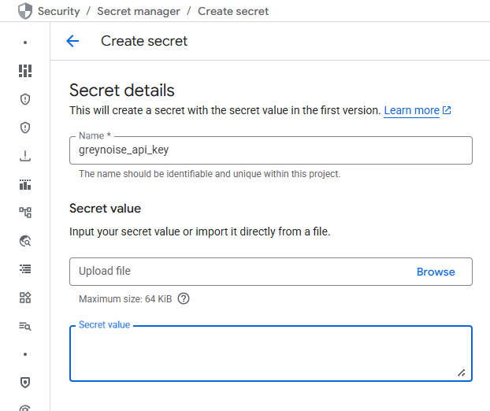

Refer to this page for more information about how to create secrets.
Once the secrets are created on Secret Manager, use the secret's resource id as the value for environment variables. For example
SECRET_KEY: projects/{project_id}/secrets/{secret_id}/versions/{version_id}

Note : Ensure that the resource ID format matches the following structure: projects/{project_id}/secrets/{secret_id}/versions/{version_id}. You can copy the resource name from the secret version details to obtain this value.

Create a GCP Bucket
- Log in to the "https://console.cloud.google.com/" using valid credentials.
- Navigate to Buckets in GCP.
- Click on the Create button.
- Enter the name of the bucket.
- Users can select the region and modify the optional parameters if required and then click on the Create button.

Copy the bucket name and provide it in the GCP_BUCKET_NAME environment variable.

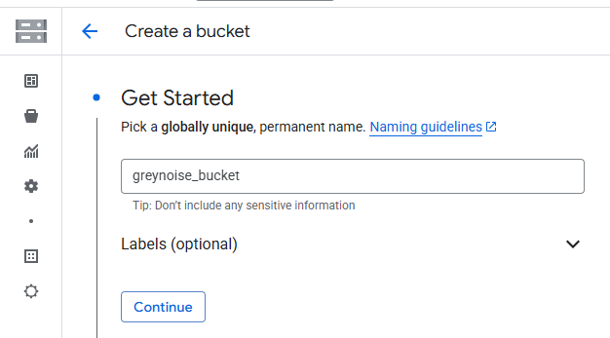

Cloud Function Deployment

Command based deployment
- Navigate to the bucket and open the bucket created for the GreyNoise in these steps. Upload the created cloud function zip file in the bucket.
- Click Activate Cloud Shell at the top right corner of the Google Cloud console.
- Modify the below command based on your value and run in the terminal.

Command Format :
gcloud functions deploy CLOUD_FUNCTION_NAME --set-env-vars “ENV_NAME1=ENV_VALUE1,ENV_NAME2=ENV_VALUE2,ENV_NAME3=ENV_VALUE3” --gen2 --runtime=python312 --region=REGION --source=SOURCE_OF_FUNCTION --entry-point=main --service-account=SERVICE_ACCOUNT_EMAIL --trigger-http --no-allow-unauthenticated --memory=8GiB --timeout=3600s

- CLOUD_FUNCTION_NAME: Unique name of the cloud function.
- REGION: A region for your cloud function. (Ex : us-central1, us-west1, etc.)
- SOURCE_OF_FUNCTION: gsutil URI of the cloud function zip in cloud storage. (e.g. gs://greynoise_test_bucket/greynoise_test.zip) where the greynoise_test_bucket is the name of the created bucket and greynoise_test.zip is the cloud function zip file.
- SERVICE_ACCOUNT_EMAIL: Email of the created service account of the project. Make sure the selected Service account must have a required permission. Update Service Account Permission following these steps.
- ENV_NAME1=ENV_VALUE1: Name and value of the environment variable to be created. Environment variables
Note:
- When deploying a Cloud Function, ensure that the --timeout parameter in the deployment command matches the frequency specified in the Cloud Scheduler --schedule parameter. Aligning these values prevents overlapping executions, which could lead to data duplication.
- For example, if you set --timeout=3600s when deploying the Cloud Function, configure the Cloud Scheduler with: --schedule="*/60 * * * *".
- This ensures that each scheduled run starts only after the previous execution has completed.

Example Command,
gcloud functions deploy funcusingcmd --set-env-vars "CHRONICLE_CUSTOMER_ID=ed19f037-2354-43df-bfbf-350362b45844,CHRONICLE_PROJECT_NUMBER=2134567,CHRONICLE_REGION=us,GCP_BUCKET_NAME=greynoise_test_bucket,GREYNOISE_API_KEY=projects/1234567890/secrets/gn_api_key/versions/1," --gen2 --runtime=python312 --region=us-central1 --source=gs://gn_test_bucket/greynoise_test.zip --entry-point=main --service-account=1234567890-compute@developer.gserviceaccount.com --trigger-http --no-allow-unauthenticated --memory=8GiB --timeout=3600s

Configure Scheduler

Command based deployment

- Click Activate Cloud Shell at the top right corner of the Google Cloud console.
- Modify the below command based on your value and run in the terminal.

Command Format :
gcloud scheduler jobs create http SCHEDULER_NAME --schedule="CRON_TIME" --uri="CLOUD_FUNCTION_URL" --http-method=POST --attempt-deadline=30m --oidc-service-account-email=SERVICE_ACCOUNT_EMAIL --location=LOCATION --time-zone=TIME_ZONE --project=CHRONICLE_PROJECT_NUMBER

- SCHEDULER_NAME: Unique name of the cloud scheduler.
- CRON_TIME: Cron time format for the scheduler to run in every interval. (eg. */60 * * * *)
- CLOUD_FUNCTION_URL: URL of the created cloud function. Navigate to create cloud function details.
- SERVICE_ACCOUNT_EMAIL: Email of the created service account of the project. Make sure the selected Service account must have a required Permission. Update Service Account Permission following these steps.
- LOCATION: A region for your connector. (Ex : us-central1, us-west1, etc)
- TIME_ZONE: The time zone of your region. (Ex : UTC)

Note:
- When deploying a Cloud Function, ensure that the --timeout parameter in the deployment command matches the frequency specified in the Cloud Scheduler --schedule parameter. Aligning these values prevents overlapping executions, which could lead to data duplication.
- For example, if you set --timeout=3600s when deploying the Cloud Function, configure the Cloud Scheduler with: --schedule="*/60 * * * *".
- This ensures that each scheduled run starts only after the previous execution has completed.

Example Command
gcloud scheduler jobs create http funcusingcmdschedular --schedule="*/60 * * * *" --uri="https://us-central1-test.cloudfunctions.net/funcusingcmd" --attempt-deadline=30m --oidc-service-account-email=1234567890-compute@developer.gserviceaccount.com --location=us-central1 --time-zone=UTC

Update Service Account Permission
- Open GCP Console, Then go to IAM.
- In View By Main Tab > Click GRANT ACCESS.
- Add Service Account name in New Principals. (Example : service_account_name.gserviceaccount.com)
- In Assign Role, assign below roles to service accounts.
  - Cloud Scheduler Job Runner
  - Secret Manager Secret Access
  - Storage Admin
  - Chronicle API Editor
  - Cloud Run Invoker
  - Role Viewer
- Click Save.

Environment Variables to be configured in Cloud Function
During the integration setup, users are required to provide environment specific values. These values can be obtained by following these steps.

Environment variable | Description | Default value | Required | Secret Manager
CHRONICLE_CUSTOMER_ID | Google SecOps customer id. Navigate to settings in the Google SecOps console for the customer id. | - | Yes | No
CHRONICLE_REGION | A region where the Google SecOps instance is located. | us | No | No
CHRONICLE_PROJECT_NUMBER | Specifies the GCP project identifier associated with your Google SecOps environment. | - | Yes | No
GCP_BUCKET_NAME | Name of the created GCP bucket. | - | Yes | No
GREYNOISE_API_KEY | Copied resource name value of API KEY of GreyNoise from secret manager.  Generate an API Key from the GreyNoise platform's API key section. | - | Yes | Yes
QUERY | A query to filter GreyNoise Indicators. More details.  Examples are below:  actor:Censys classification:benign | last_seen:1d | No | No

Live Investigation

Trigger a live investigation whenever you need GreyNoise intelligence for a short list of IPs on demand rather than waiting for the scheduled ingest job.

Steps to perform live Investigation:
- Create a Google SecOps data table containing the IPs to be investigated so the live investigation can pull IPs directly from the Google SecOps data table and investigate them via GreyNoise. To build or update the table, follow the steps here.
- Open the deployed GreyNoise Cloud Function in the Google Cloud Console and click on the Test button.
- In Configure Payload, supply the payload shown in below format. Include whichever inputs apply to your investigation.
- Click Test in Cloud Shell and, once the terminal opens, press Enter to begin the run.
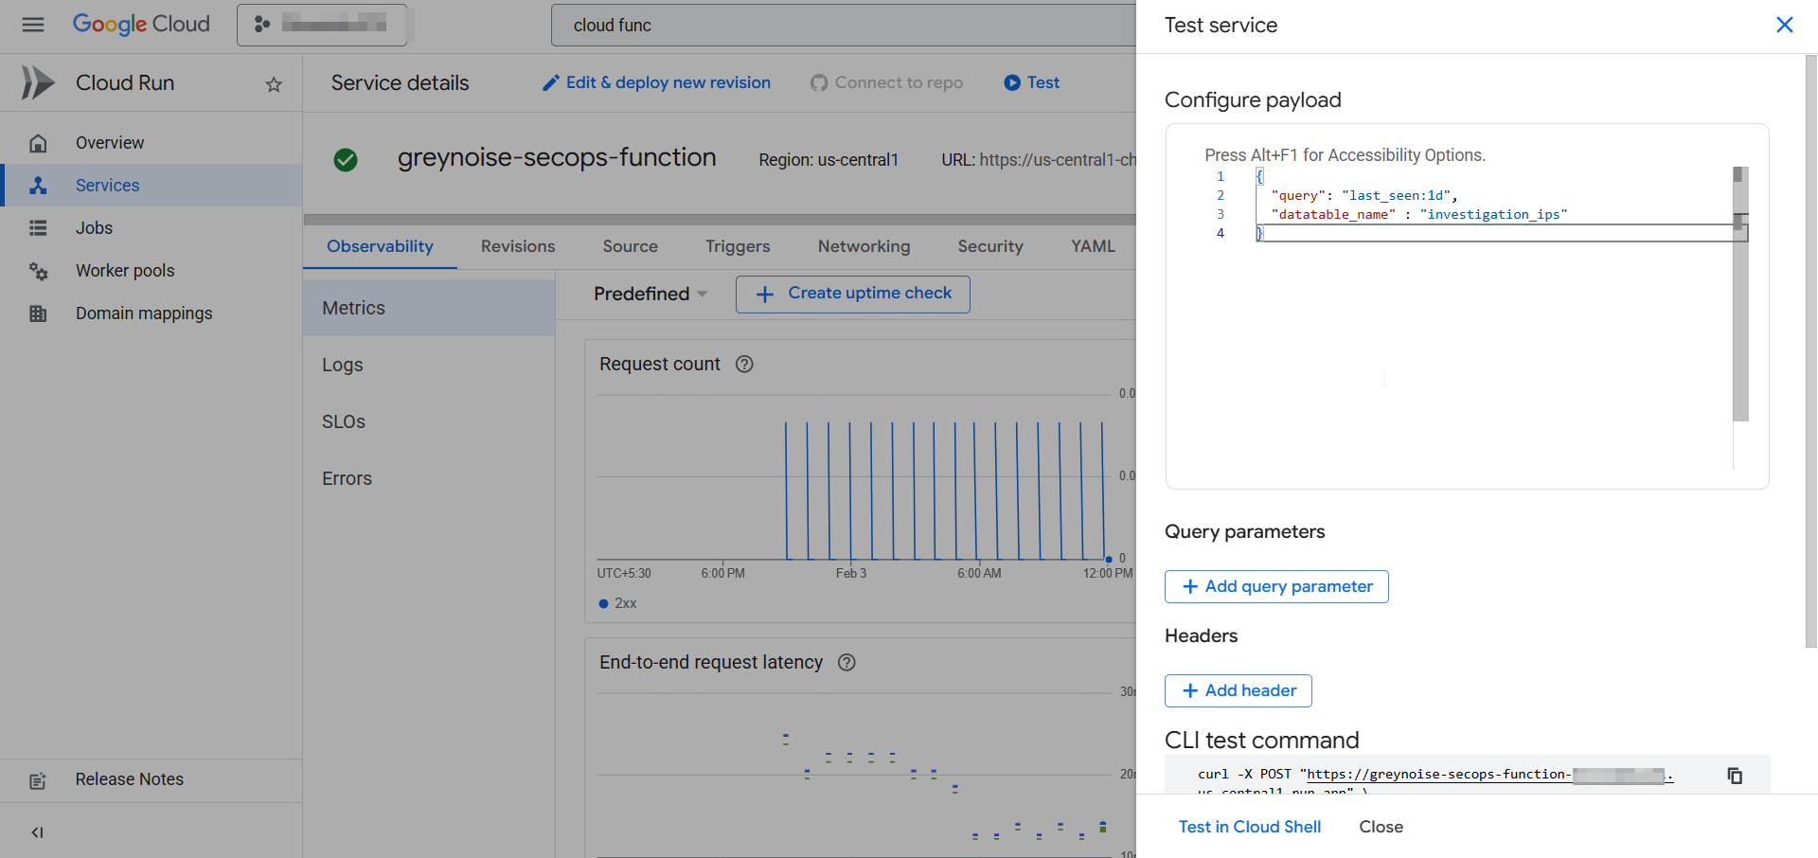
- The ad-hoc Python script fetches GreyNoise intelligence and ingests the resulting entities into Google SecOps.
- Track progress in the Cloud Function Logs tab.

Payload format
{
"query": "<query for investigation>",
"datatable_name": "<name of datatable>"
}

Note:
  - Providing only a query automatically scopes results to last_seen:1d unless you provide last_seen:{x}d yourself.
  - Providing only a datatable_name iterates through each valid IP in that table, invalid IPs are ignored.
  - Providing both inputs runs the query for every valid IP returned from the data table.
  - Leaving both inputs empty causes the script to exit with an error.

View Events in Google SecOps
- Log in to Google SecOps:
  - Open a web browser and navigate to the Google SecOps instance URL. For example: https://test.backstory.chronicle.security/
  - Replace test with your actual Google SecOps instance name.
- Access SIEM Search:
  - From the top left corner of the Google SecOps console, select the "Investigation" option.
  - Within the Investigation section, choose "SIEM Search".
- Filter Events by Log Type:
  - In the SIEM Search interface, locate the "UDM Search" section.
  - Apply a filter for the metadata field "log_type". Set the filter value to metadata.log_type="GREYNOISE”.
- View GreyNoise Intelligence Entities:
  - The SIEM Search results will display GreyNoise Intelligence entities within the "Results" section.

Redeploying an Upgraded Build
Run the same Automatic or Manual steps with the new Cloud Function ZIP. Use the same function name so GCP updates the code automatically.

Deployment Steps:
Automatic: Rerun the bash script to provide the updated ZIP, and reuse the earlier configuration values (Project ID, API key, etc.).

Manual: Rerun the gcloud functions deploy command, point the source flag to the latest ZIP, and keep the function name unchanged.

Important Notes:
- Same function name means the old build is overwritten, no extra cleanup required.
- Cloud Scheduler, Secret Manager, and service-account settings stay valid.
- After redeploying, check Cloud Logging to confirm everything runs without errors.

Detection Rules

Create Detection Rules
After collecting the data into Google SecOps in the form of entities, the user can see the specific entities from predefined saved searches.

Create & Enable Detection Rule
- From Google SecOps SIEM, navigate to Detection > Rules & Detections.
- Go to the Rules Editor Tab, click on the NEW button.
- Copy and paste the Rule in editor.
- Click on SAVE NEW RULE.
- Click on 3 dots on the top right of the editor.
- To generate alerts, Enable Alerting
- Enable Live Rule to activate Detection Rule.

See Google SecOps: Detection Rules for more information.

Detection Rules

GreyNoise Intelligence Brute Force Attack Detection
Description: Detects multiple blocked login attempts from IPs flagged by GreyNoise threat intelligence.
Rule:
rule greynoise_intelligence_brute_force_attack_detection {

meta:
author = "GreyNoise Intelligence"
rule_name = "GreyNoise Intelligence Brute Force Attack Detection"
description = "Detects multiple blocked login attempts from IPs flagged by GreyNoise threat intelligence."
severity = "High"
priority = "High"
mitre_attack_tactic = "Credential Access"
mitre_attack_technique = "T1110 - Brute Force"
tags = "cloud security, threat intelligence"

events:
$login.metadata.event_type = "USER_LOGIN"
$login.security_result.action = "BLOCK"
(
$login.src.ip = $correlation_ip or
$login.principal.ip = $correlation_ip
)

// GreyNoise entity match
$greynoise.graph.metadata.event_metadata.base_labels.log_types = "GREYNOISE"
$greynoise.graph.metadata.product_name = "GreyNoise Intelligence"
$greynoise.graph.metadata.entity_type = "IP_ADDRESS"
$greynoise.graph.entity.ip = $correlation_ip

match:
$correlation_ip over 15m

outcome:
$principal_ip = array_distinct($login.principal.ip)
$principal_hostname = array_distinct($login.principal.hostname)
$principal_user_userid = array_distinct($login.principal.user.userid)
$principal_mac = array_distinct($login.principal.mac)
$principal_ip_count = count($login.principal.ip)

$source_ip = array_distinct($login.src.ip)
$source_hostname = array_distinct($login.src.hostname)
$source_user_userid = array_distinct($login.src.user.userid)
$source_mac = array_distinct($login.src.mac)
$source_ip_count = count($login.src.ip)

$target_ip = array_distinct($login.target.ip)
$target_hostname = array_distinct($login.target.hostname)
$target_user_userid = array_distinct($login.target.user.userid)
$target_mac = array_distinct($login.target.mac)

condition:
$login and $greynoise and ($principal_ip_count>5 or $source_ip_count>5)
}

GreyNoise Intelligence Inbound Network Traffic with ASN Context
Description: Detects allowed inbound firewall connections from malicious IPs flagged by GreyNoise with correlated ASN context.
Rule:
rule greynoise_intelligence_inbound_network_traffic_with_asn_context {

meta:
author = "GreyNoise Intelligence"
rule_name = "GreyNoise Intelligence Inbound Network Traffic with ASN Context"
description = "Detects allowed inbound firewall connections from malicious IPs flagged by GreyNoise with correlated ASN context."
severity = "High"
priority = "Critical"
mitre_attack_tactic = "Initial Access"
tags = "cloud security, threat intelligence"

events:
$network.metadata.event_type = "NETWORK_CONNECTION"
$network.security_result.action = "ALLOW"
re.regex($network.metadata.product_name, `(?i).*firewall.*`)
(
$network.src.ip = $correlation_ip or
$network.principal.ip = $correlation_ip
)

// GreyNoise entity match
$greynoise.graph.metadata.event_metadata.base_labels.log_types = "GREYNOISE"
$greynoise.graph.metadata.product_name = "GreyNoise Intelligence"
$greynoise.graph.metadata.entity_type = "IP_ADDRESS"
$greynoise.graph.metadata.threat.threat_verdict = "MALICIOUS"
$greynoise.graph.entity.ip = $correlation_ip
(
re.capture($network.principal.ip_geo_artifact.network.asn, `(\d+)`) = re.capture($greynoise.graph.entity.ip_geo_artifact.network.asn, `(\d+)`)
or
re.capture($network.src.ip_geo_artifact.network.asn, `(\d+)`) = re.capture($greynoise.graph.entity.ip_geo_artifact.network.asn, `(\d+)`)
)

match:
$correlation_ip over 1h

outcome:
$principal_ip = array_distinct($network.principal.ip)
$principal_hostname = array_distinct($network.principal.hostname)
$principal_user_userid = array_distinct($network.principal.user.userid)
$principal_mac = array_distinct($network.principal.mac)

$source_ip = array_distinct($network.src.ip)
$source_hostname = array_distinct($network.src.hostname)
$source_user_userid = array_distinct($network.src.user.userid)
$source_mac = array_distinct($network.src.mac)

$target_ip = array_distinct($network.target.ip)
$target_hostname = array_distinct($network.target.hostname)
$target_user_userid = array_distinct($network.target.user.userid)
$target_mac = array_distinct($network.target.mac)

condition:
$network and $greynoise
}

GreyNoise Intelligence IP Match
Description: Detects events where source or principal IP matches a malicious or suspicious IP in GreyNoise intelligence.
Rule:
rule greynoise_intelligence_ip_match {

meta:
author = "GreyNoise Intelligence"
rule_name = "GreyNoise Intelligence IP Match"
description = "Detects events where source or principal IP matches a malicious or suspicious IP in GreyNoise intelligence."
severity = "High"
priority = "Medium"
tags = "cloud security, threat intelligence"

events:
$network.metadata.event_type != "GENERIC_EVENT"
(
$network.src.ip = $correlation_ip or
$network.principal.ip = $correlation_ip
)

// GreyNoise entity match
$greynoise.graph.metadata.event_metadata.base_labels.log_types = "GREYNOISE"
$greynoise.graph.metadata.product_name = "GreyNoise Intelligence"
$greynoise.graph.metadata.entity_type = "IP_ADDRESS"
(
$greynoise.graph.metadata.threat.threat_verdict = "MALICIOUS"
or
$greynoise.graph.metadata.threat.threat_verdict = "SUSPICIOUS"
)
$greynoise.graph.entity.ip = $correlation_ip

match:
$correlation_ip over 1h

outcome:
$principal_ip = array_distinct($network.principal.ip)
$principal_hostname = array_distinct($network.principal.hostname)
$principal_user_userid = array_distinct($network.principal.user.userid)
$principal_mac = array_distinct($network.principal.mac)

$source_ip = array_distinct($network.src.ip)
$source_hostname = array_distinct($network.src.hostname)
$source_user_userid = array_distinct($network.src.user.userid)
$source_mac = array_distinct($network.src.mac)

$target_ip = array_distinct($network.target.ip)
$target_hostname = array_distinct($network.target.hostname)
$target_user_userid = array_distinct($network.target.user.userid)
$target_mac = array_distinct($network.target.mac)

condition:
$network and $greynoise
}

Saved Searches

Create Saved Searches
After collecting the data into Google SecOps in the form of entities, the user can see the specific entities from predefined saved searches.

Create & Execute a Saved Search
- From Google SecOps SIEM, navigate to Investigation > SIEM Search.
- Go to Search Manager, click on + icon.
- Copy and paste the Search Query in UDM SEARCH, Title in Title and Description in Description from the Search Queries listed below.
- Click on SAVE EDITS.
- Click on LOAD SEARCH.
- Select Time Range.
- Click on Run Search to execute the search query.

See Google SecOps: Saved Searches for more information.

Saved Searches

GreyNoise - IP Risk & Vulnerability Details
Description: Comprehensive security view of GreyNoise indicators including classification, anonymization signals, associated CVEs, and activity timeline.

Query:
graph.metadata.vendor_name = "GreyNoise Intelligence"
graph.metadata.product_name = "GreyNoise Intelligence"
$ip = graph.entity.ip
$classification = graph.metadata.threat.threat_verdict
$bot = strings.to_upper(graph.metadata.threat.detection_fields["bot"])
$tor = strings.to_upper(graph.metadata.threat.detection_fields["tor"])
$spoofable = strings.to_upper(graph.metadata.threat.detection_fields["spoofable"])
$vpn_Service = if(graph.metadata.threat.detection_fields["vpn"]= "true", graph.metadata.threat.detection_fields["vpn_service"], "-")
$time = timestamp.get_timestamp(graph.metadata.collected_timestamp.seconds, "%Y-%m-%d %H:%M:%S")
$first_seen_date = timestamp.get_timestamp(graph.metadata.threat.first_discovered_time.seconds, "%Y-%m-%d")
$category = graph.additional.fields["network_category"]
$category = /.*/
graph.entity.asset.vulnerabilities.cve_id = /.*/
match:
$ip, $classification, $category, $bot, $tor, $vpn_Service, $spoofable, $first_seen_date
outcome:
$all_cves = re.replace((arrays.join_string(array_distinct(if(graph.entity.asset.vulnerabilities.cve_id!="", graph.entity.asset.vulnerabilities.cve_id, "-")),", ")), "(, -)|(-, )","")
$last_seen = window.last(graph.metadata.collected_timestamp.seconds, $time)
order:
$last_seen desc
limit:
10000

GreyNoise - Indicator Context Summary
Description: Provides actor attribution, geographic details, organization info, and tags for quick indicator triage and contextual analysis.

Query:
graph.metadata.vendor_name = "GreyNoise Intelligence"
graph.metadata.product_name = "GreyNoise Intelligence"
$ip = graph.entity.ip
$classification = graph.metadata.threat.threat_verdict
$actor = graph.additional.fields["internet_scanner_actor"]
$country = graph.entity.ip_geo_artifact.location.country_or_region
$organization = graph.entity.ip_geo_artifact.network.organization_name
$category = graph.additional.fields["network_category"]
$description = graph.metadata.description
$summary = graph.metadata.threat.summary
$time = timestamp.get_timestamp(graph.metadata.collected_timestamp.seconds, "%Y-%m-%d %H:%M:%S")
$first_seen_date = timestamp.get_timestamp(graph.metadata.threat.first_discovered_time.seconds, "%Y-%m-%d")
match:
$ip, $classification, $description, $summary, $actor, $country, $organization, $category, $first_seen_date
outcome:
$last_seen = window.last(graph.metadata.collected_timestamp.seconds, $time)
$primary_tag = re.replace((arrays.join_string(array_distinct(if(graph.entity.artifact.tags!="", graph.entity.artifact.tags, "-")),", ")), "(, -)|(-, )","")
order:
$last_seen desc
limit:
10000

GreyNoise - High Risk Indicators
Description: Lookup filter to quickly identify indicators classified as MALICIOUS or SUSPICIOUS that require immediate investigation.

Query:
graph.metadata.product_name = "GreyNoise Intelligence"
graph.metadata.vendor_name = "GreyNoise Intelligence"
$classification = graph.metadata.threat.threat_verdict
$classification = "MALICIOUS" or $classification = "SUSPICIOUS"

GreyNoise - All Indicator Lookup
Description: Browse all ingested GreyNoise indicators with business service context. Use as a starting point for ad-hoc investigations.

Query:
graph.metadata.vendor_name = "GreyNoise Intelligence"
graph.metadata.product_name = "GreyNoise Intelligence"
graph.entity.ip = /.*/
graph.additional.fields["business_service_found"] = /.*/ nocase

Dashboard Configuration

Import GreyNoise Dashboard into Google SecOps SIEM
Complete the following steps to import a dashboard:
- Log in to your Google SecOps instance.
- In the navigation bar, click Dashboards & Reports > Dashboards.
- Click New dashboard and then select Import from JSON. The Import dashboard confirmation dialog appears.
- Click the Upload dashboard files button. The Select file dialog appears. Select the dashboard json file. The selected dashboard file will appear in the table.
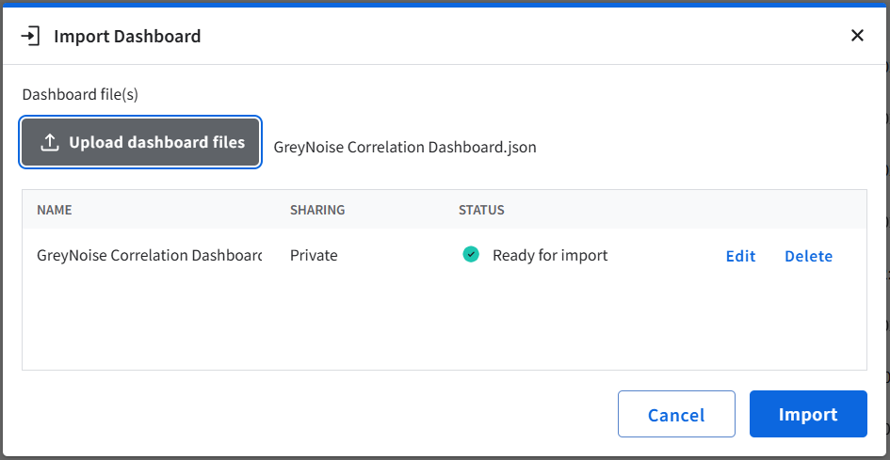
- Click Import to continue importing the dashboard to a personal or shared dashboard.

Dashboards

Indicator Dashboard
The Indicator Dashboard provides detailed information about Indicators fetched from GreyNoise.

Filters Description

Indicator Active Time
  - This filter updated the panel based on the time range selected in it. Default: Last 7 days.

Classification Filter
  - Filters the Panels according to the selected Classification type. i.e. SUSPICIOUS, MALICIOUS etc. Default: All.

Country Filter
  - Filters the Panels according to the entered Country. Default: All.

Panels Description

Unique IP Addresses in GreyNoise
  - Count of distinct IPs in GreyNoise threat intelligence.

Malicious IP Addresses in GreyNoise
  - Count of IPs identified as Malicious in GreyNoise threat intelligence.

Suspicious IP Addresses in GreyNoise
  - Count of IPs identified as Suspicious in GreyNoise threat intelligence.

Benign IP Addresses in GreyNoise
  - Count of IPs identified as Benign in GreyNoise threat intelligence.

Unknown IP Addresses in GreyNoise
  - Count of IPs with no definitive classification in GreyNoise threat intelligence.

Indicators by Classification
  - Distribution of indicators by Threat Verdict Unspecified, Malicious, Suspicious & Undetected.

Business Service IP Intelligence
  - List of IP addresses identified as Business Services, including service category, trust level, and descriptive context.

Business Service IPs by Trust Level
  - Business service IPs segmented by trust levels

Top 10 Organizations
  - Highlights organizations (ISPs/Hosting Providers) most frequently associated with observed indicators.

Top 10 Actors
  - Identifies the most frequently observed threat actors across all indicators.

Top 10 Tags
  - Lists the most common tags associated with observed indicators.

Top 10 ASN
  - Displays the top autonomous system numbers related to indicator activity.

Top 10 Categories
  - Displays the most prevalent network categories.

Top 10 OS
  - Shows the top operating systems identified from Indicator metadata.

Top 10 Business Service Categories
  - Highlights business service categories most often linked to indicators.

Top 10 Source Countries
  - Shows the top Source Countries linked to Indicators.

IPs Over Time (Ingested Indicators Trend)
  - Trend of ingested indicators over time by classification.

Indicator Details (All Ingested IPs)
  - Recently ingested IP indicators with details.

CVE Distribution
  - CVEs associated with observed IPs.

Manually Queried Indicator
  - Displays indicators that were manually investigated by users.

Screenshots
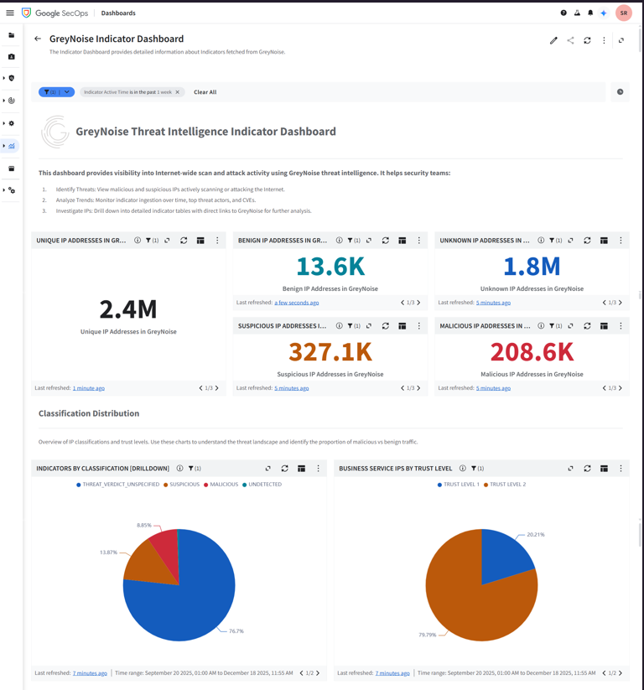
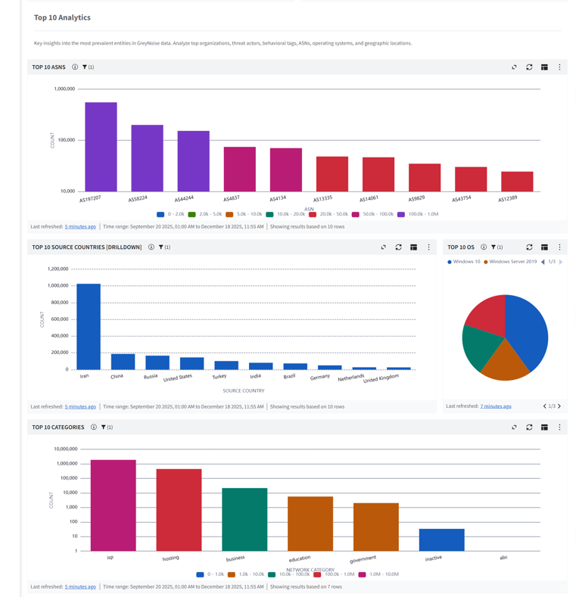
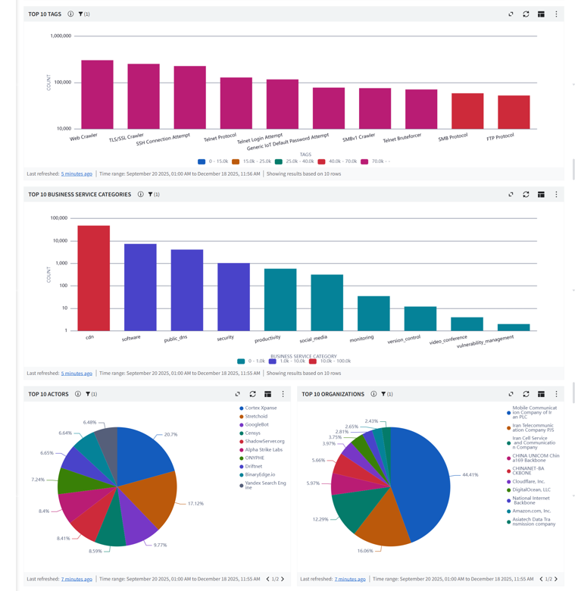
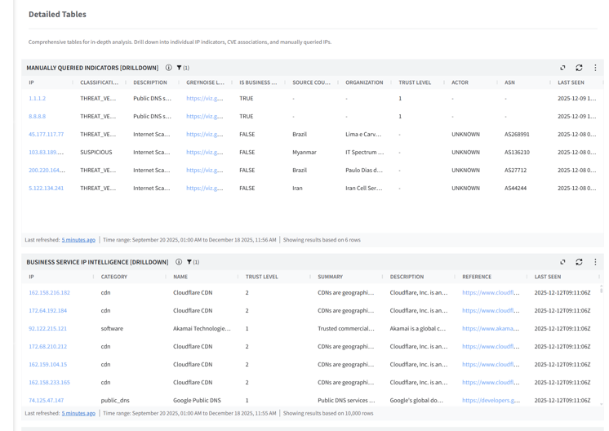
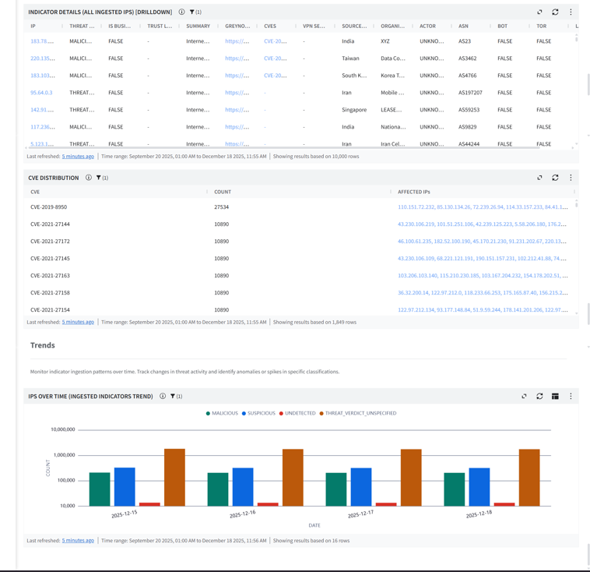

Correlation Dashboard
The Correlation dashboard is designed to identify relationships across indicators and events from other sources.

Filters Description

Indicator Active Time Range
  - This filter updated the panel based on the time range selected in it. Default: Last 7 days.

Classification Filter
  - Filters the Panels according to the selected Classification type. i.e. SUSPICIOUS, MALICIOUS etc. Default: All.

Panels Description

GreyNoise Unique IOC Matches
  - Total count of GreyNoise Intelligence IOC matches detected in the environment.

Event Matches In last 24 Hours
  - Count of GreyNoise Intelligence IOC matches detected in the environment in the last 24 hours.

Malicious IPs
  - Count of IPs classified as malicious by GreyNoise Intelligence.

Suspicious IPs
  - Count of IPs classified as suspicious by GreyNoise Intelligence.

Benign IPs
  - Count of IPs classified as benign by GreyNoise Intelligence.

Unknown IPs
  - Count of IPs classified as unknown by GreyNoise Intelligence.

Total Event Matches
  - Count of distinct IP addresses matched against GreyNoise Intelligence.

Top 10 IP Indicators
  - Table of the 10 most frequently matched IPs from GreyNoise Intelligence with hostname details.

IOC by Classification
  - Pie chart showing GreyNoise Intelligence IOC distribution by classification.

IOC Matches Over Time by Category
  - Bar chart showing GreyNoise Intelligence IOC match trends grouped by category.

Top 10 Rarely Seen IP
  - Table of the 10 least frequently matched IPs from GreyNoise Intelligence.

Top 10 Categories
  - Pie chart visualizing the top 10 IOC categories of GreyNoise Intelligence IOC matches.

IOCs Geolocation Overview
  - World map plotting the geographic origin of matched GreyNoise Intelligence IOCs.

Correlation Overview
  - Comprehensive investigation table displaying GreyNoise Intelligence IOC matches for in-depth analysis.
Screenshot
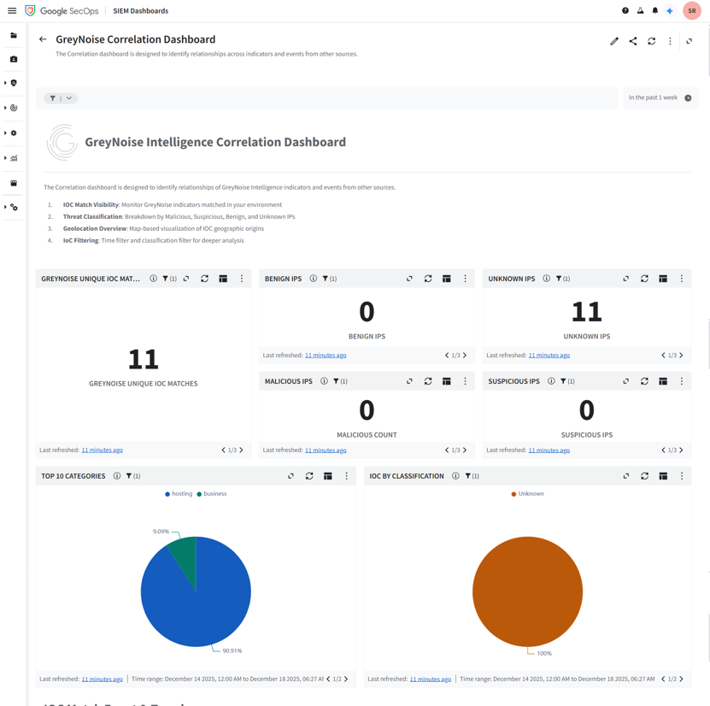
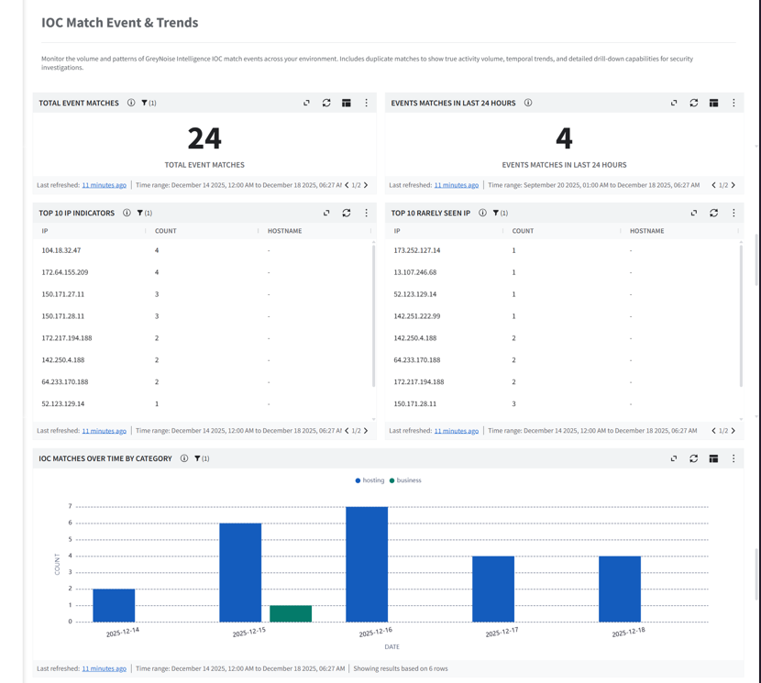
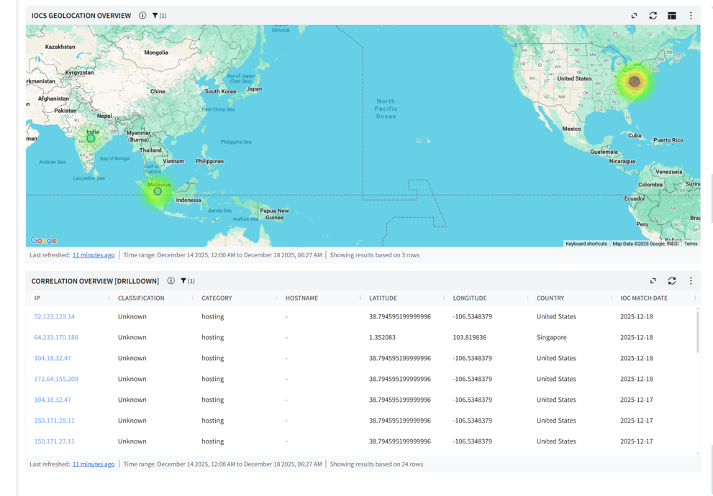

Locate Environment Variables

CHRONICLE_CUSTOMER_ID
Steps to find:
- Log in to the GCP console (console.cloud.google.com).
- From the GCP Navigation Menu, Navigate to Security > Google SecOps.
- Expand Instance details.
- Copy the Customer ID value.

CHRONICLE_REGION
Steps to find:
- Log in to the GCP console (console.cloud.google.com).
- Navigate to Security > Google SecOps.
- Expand Instance details.
- Copy the Region value.

CHRONICLE_PROJECT_NUMBER
Steps to find:
- Log in to the GCP console (console.cloud.google.com).
- On the home page you can find Project number.

GCP_BUCKET_NAME
Steps to find:
- Log in to the GCP console (console.cloud.google.com).
- From the GCP Navigation Menu, Cloud Storage > Buckets.
- Copy the bucket name (e.g., greynoise-bucket).

GREYNOISE_API_KEY
Steps to find:
- Navigate to the : https://viz.greynoise.io/account/api-key .
- Copy the API Key.

QUERY
Steps to find:
- Refer to the GreyNoise Query Language documentation
- Construct your query based on filtering requirements.

Limitations

- If the user does not specify the required environment variable while configuring the Cloud Function, the script deployment will fail.
- CBN parser will only be able to parse the GreyNoise entity data.
- The Google SecOps Ingestion API has a payload limit of 4 MB. Logs exceeding this limit will not be ingested and will be skipped. To minimize data loss, please ensure that log sizes remain within the allowed limit.
- Newly ingested entities often take additional time to appear on the dashboard. This latency impacts real time monitoring and reduces the effectiveness of dashboards for time sensitive investigations. A support ticket was raised regarding this issue for further investigation and resolution and its limitation from Google SecOps side.
- When Cloud Run functions execute for more than 30 minutes, Cloud Scheduler will show a "Failed" status with 504 Gateway Timeout errors. This is expected behavior and does not indicate actual function failure. The Cloud Run function continues execution despite the timeout in Cloud Scheduler.
Error Message Example:
ERROR <timestamp> [httpRequest.requestMethod:POST] [httpRequest.status: 504] [httpRequest.responseSize: 72 B] [httpRequest.latency:1,799.798 s] [httpRequest.userAgent:Google-Cloud-Scheduler] https://<cloud_function_uri>
- Google SecOps does not enforce validation on time range filters. Users can configure a start time greater than the end time, or set both values to be identical, without receiving an error. Filter validation logic is platform managed and cannot be extended.
- Time range granularity in Google SecOps follows calendar-based logic. Selecting "Past 1 Week" on a Monday considers the Monday-to-Sunday range, potentially returning only the current day's data if selected at the start of a week. Similar behavior applies to monthly filters.

Troubleshooting

This section describes the common issues that might happen during the deployment or the running of the app and the steps to resolve the issues.

- GCloud logs can be used for troubleshooting.
  - Log in to the "https://console.cloud.google.com/" using valid credentials.
  - Navigate to 'Cloud functions' and click on the deployed function where you can find the logs module.
  - Logs can be filtered using severity.
- If you test the cloud function immediately after deploying it on gcloud, It might be possible that the cloud function will not work as expected. To resolve this, wait for a few seconds and then test it.
- If the cloud function stops its execution because memory exceeds the limit, reconfigure the cloud function’s memory configuration and increase the memory limit.
- The dashboard may be slow to load or unresponsive - This could be due to a problem with the data source being unavailable or having too much data, the query that is being used, or the way that the dashboard is being rendered.
- Entities are successfully ingested but not displayed in search results this could be due to following reasons.
  - The time range for the search is outside of the timestamp associated with the ingested event.
  - The ingested entity might be a duplicate entity with the same payload.

GCP Resources/Services Approximate Cost Details

Service | Standard Configurations | Purpose | Reference
Cloud Functions | Type: Memory: 8192MB CPU: 4.8GHz  Execution time per function (ms): 3600  Invocations per month: 1500  Minimum number of instances: 1 | Function / Script which pulls data from GreyNoise Platform using API and ingest into Google SecOps. | Approx cost ~ $66/month  https://cloud.google.com/functions/pricing
Cloud Storage (Bucket) | Total Amount of Storage: 1 GiB | Storage bucket used to manage API checkpoints | Approx cost ~ $0.02/month  https://cloud.google.com/storage/pricing
Secret Manager | Access operations: 1500 | Used to maintain credentials. | Approx cost ~ $0/month  https://cloud.google.com/secret-manager/pricing
Cloud Scheduler | Total amount of jobs: 1 | Scheduler which executes above cloud function at a specific time interval. | Approx cost ~ $0/month  https://cloud.google.com/scheduler/pricing
Note: Users can also calculate (using pricing calculator) the estimated price of the Google Cloud services used.

